Programming Technology
Assignment 2



Ramzan Muhammad (PN8UOM)

Description of the Game:
Connect Four:
Connect Four is a two-player game. The discs of the first player are marked with X, and the discs of the second player are marked with O. The players take turns dropping their disc from the top into a n-column, m-row vertically suspended grid. The pieces fall straight down, occupying the lowest available space within the column. The objective of the game is to be the first to form a horizontal, vertical, or diagonal line of four of one's own discs. If the grid becomes full, the result is draw. Implement this game, and let the grid size be selectable (8x5, 10x6, 12x7). The game should recognize if it is ended, and it has to show the name of the winner in a message box (if the game is not ended with draw), and automatically begin a new game.
UML Diagram:
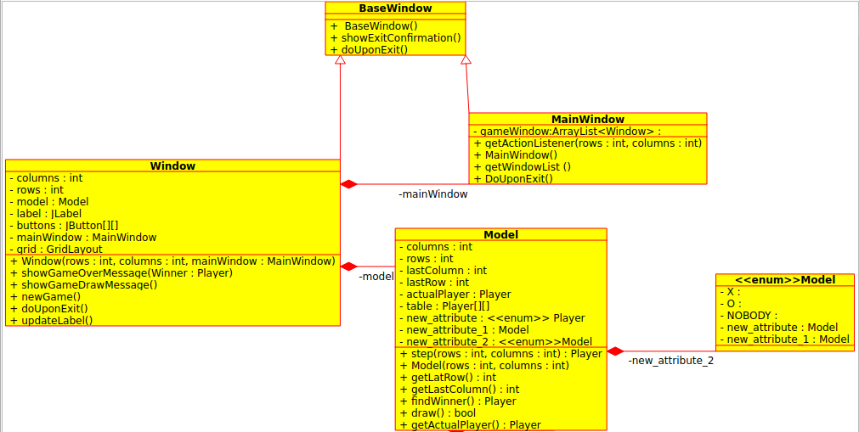

TestNo1 Showing the Main Window
So our main window looks like this

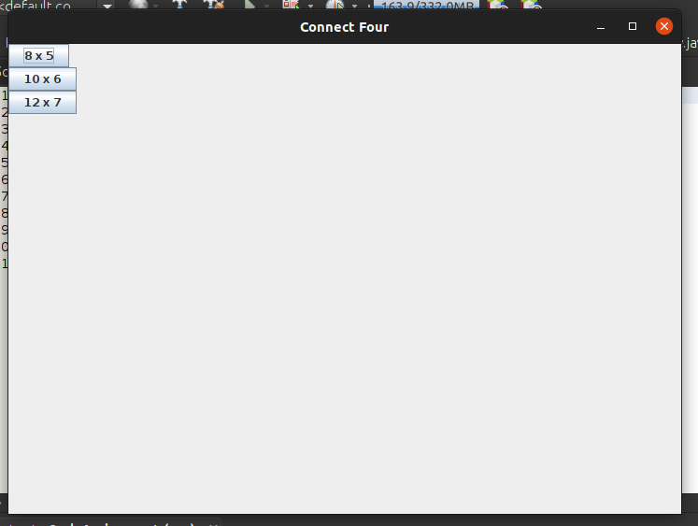

TestNo2 For 8 X 5 Window

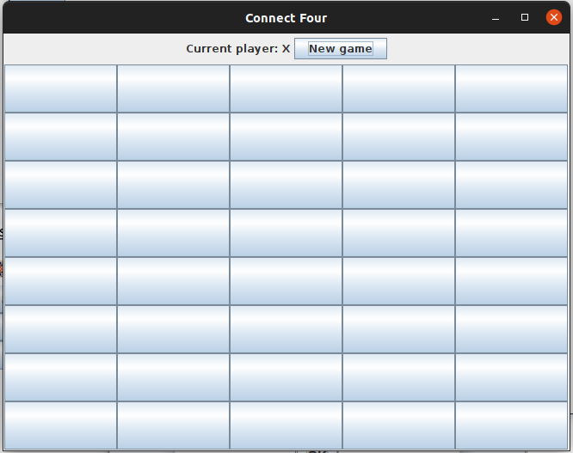

TestNo3 For 10 X 6 Window
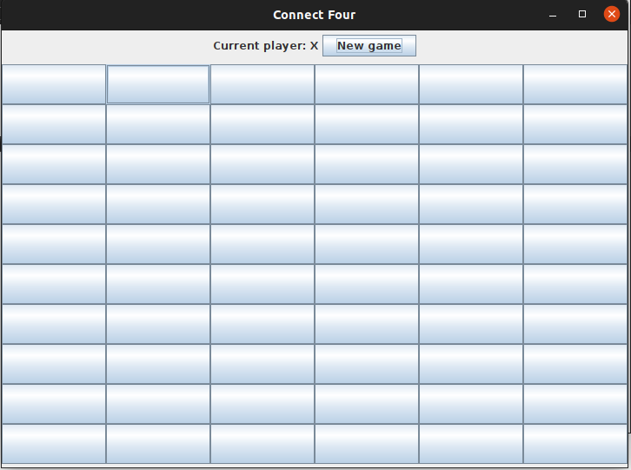

TestNo4 For 12 X 7 Window
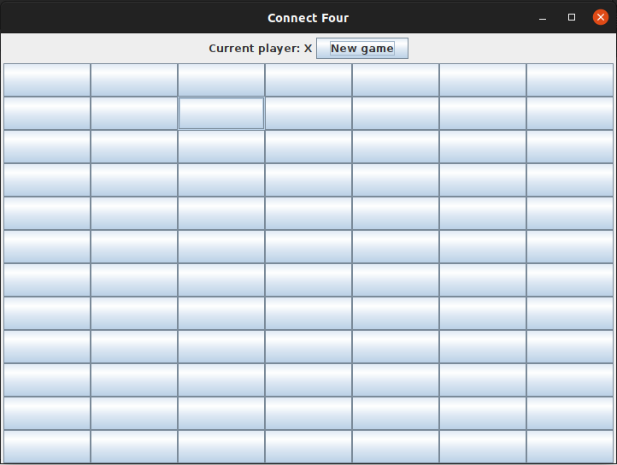

TestNo5 For checking X winner across the row
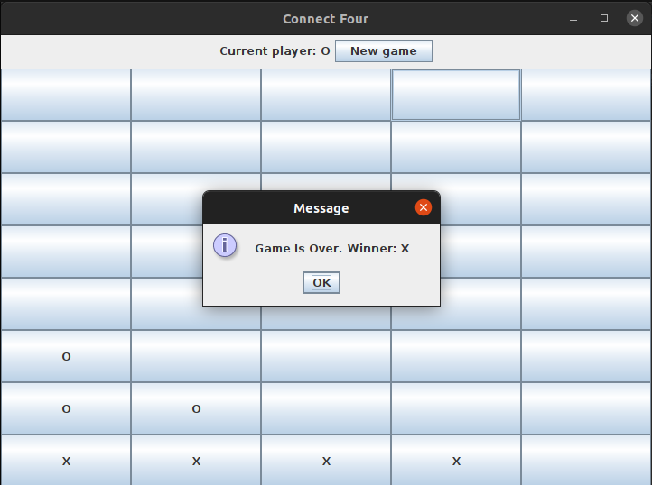

TestNo6 For checking O winner across the row
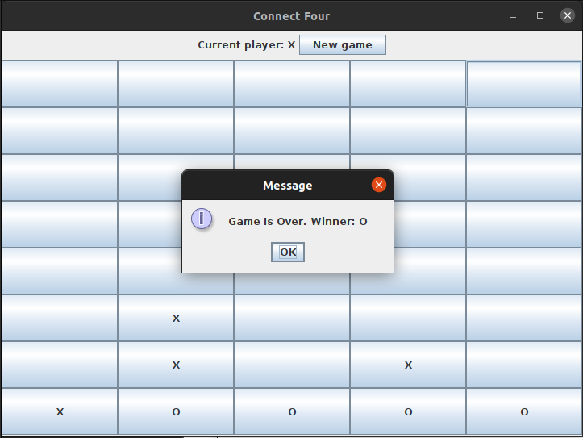

TestNo7 For checking X winner across the column

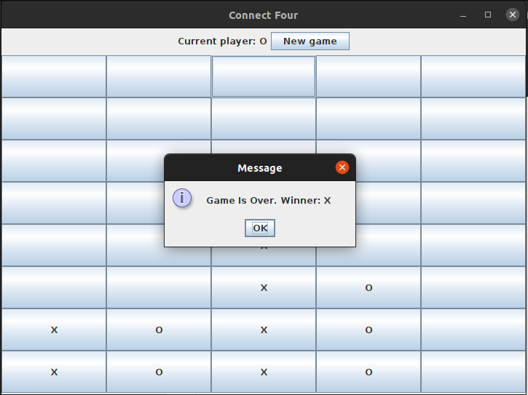

TestNo8 For checking O winner across the column

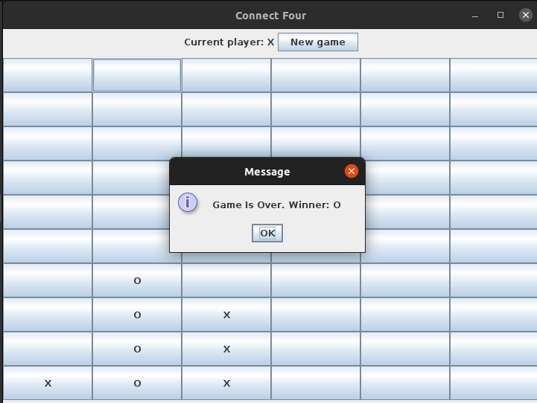

TestNo9 For checking X winner across the diagonal

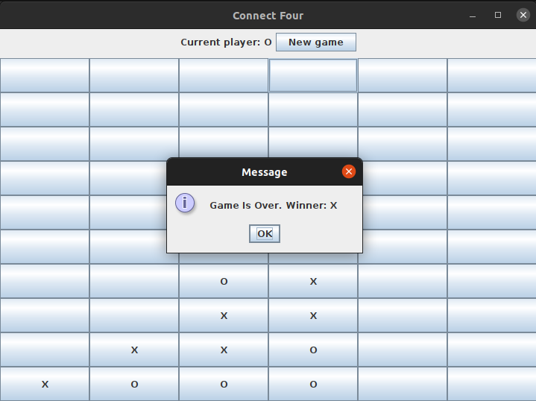

TestNo10 For checking O winner across the diagonal
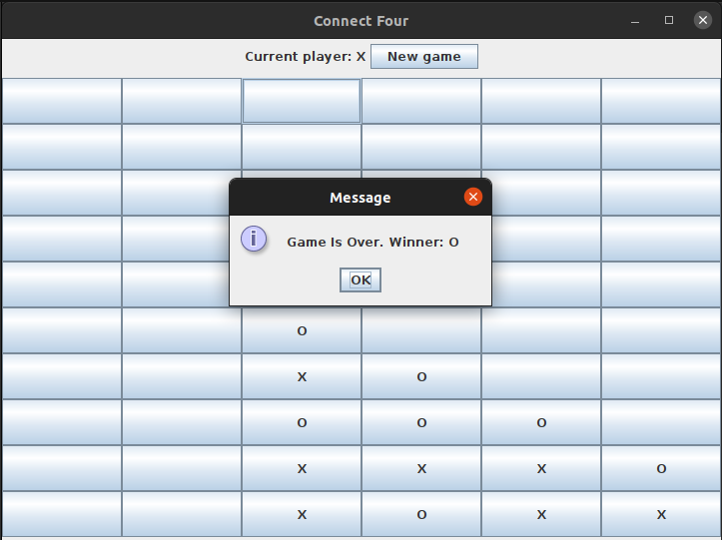

TestNo11 For checking Draw
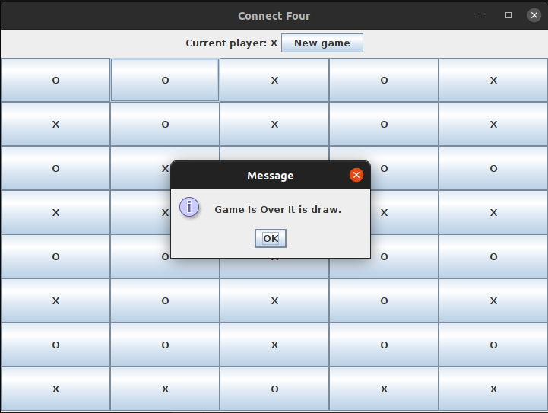

TestNo12 For Exit the Game
